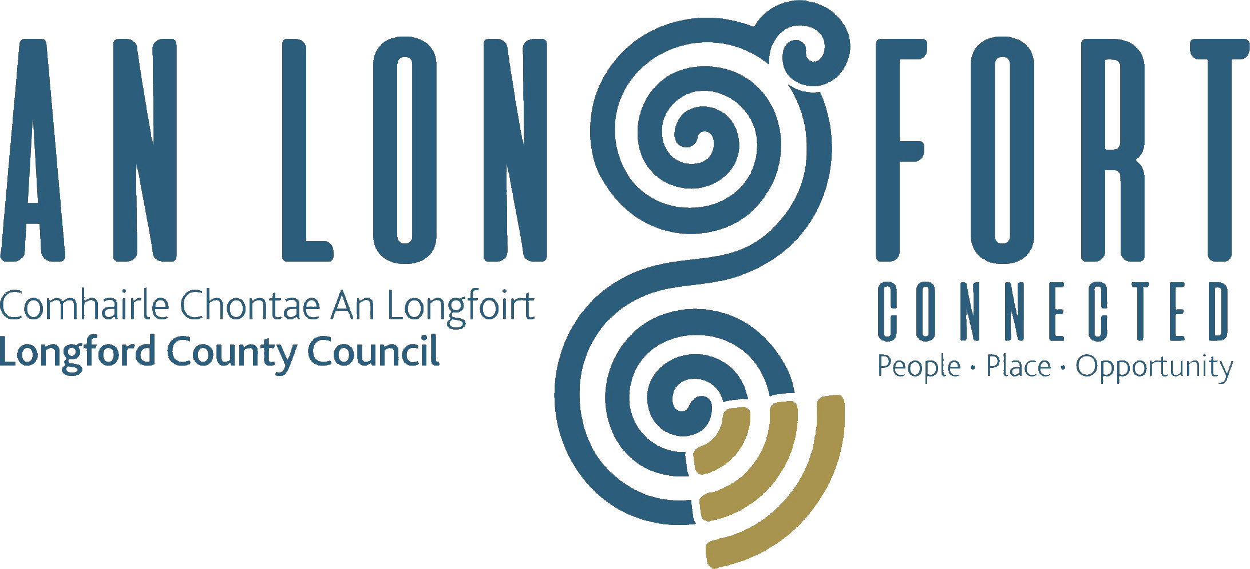

BALLYMAHON MUNICIPAL DISTRICT

Minutes of Annual Meeting of Ballymahon Municipal District held in Ballymahon Community Library on Thursday, 21st June 2018 at 4.30 p.m.

CATHAOIRLEACH: Councillor Gerard Farrell

MEMBERS PRESENT: Councillors – Mick Cahill, Mark Casey,
Colm Murray, Pat O’Toole and Paul Ross.

IN ATTENDANCE: Ms. Barbara Heslin, Director of Services.
Ms. Linda Higgins, Administrative Officer

APOLOGY: Mr. Paul Newell, Senior Executive Engineer.

MEETINGS
ADMINISTRATOR: Ms. Anne Lee.

2018 ANNUAL MEETING.

The outgoing Cathaoirleach, Councillor Gerard Farrell, spoke regarding his year as Cathaoirleach of the Municipal District. Councillor Farrell stated that it had been a privilege to serve as Cathaoirleach of the Municipal District and thanked the Elected Members; Barbara Heslin; the Municipal District support staff; Branch Library staff and the Meetings Administrator for their help and assistance over the last year. Councillor Farrell thanked the local media for their coverage of the Municipal District meetings during the previous twelve months. He referred to a number of positive developments in the Municipal District during the year including the provision of social housing in Lanesboro, progression of Center Parcs, streetscape project in Lanesboro.

The Members of the Municipal District congratulated the outgoing Cathaoirleach on his year.

ELECTION OF CATHAOIRLEACH:

On the proposal of Councillor C. Murray seconded by Councillor M. Cahill , it was unanimously agreed that Councillor Paul Ross be elected Cathaoirleach of the Municipal District.

As there was no other nomination, Councillor Ross was, thereby, elected Cathaoirleach of the Municipal District until the date of the Annual Meeting of Ballymahon Municipal District in 2019.

Councillor Ross thanked his proposer and seconder and the Members for electing him as Cathaoirleach of the Municipal District for the coming twelve months.
Councillor Ross stated that he is looking forward to working with the Municipal District members and support staff during his term as Cathaoirleach. He extended best wishes to the outgoing Cathaoirleach, Councillor Farrell.

ELECTION OF LEAS CATHAOIRLEACH:

On the proposal of Councillor M. Cahill seconded by Councillor C. Murray, it was unanimously agreed that Councillor Pat O’Toole be elected Leas Cathaoirleach of the Municipal District.

As there was no other nomination, Councillor O’Toole was, thereby, elected Leas Cathaoirleach of the Municipal District until the date of the Annual Meeting of Ballymahon Municipal District in 2019.

The Members joined in wishing Councillors Ross and O’Toole every success during their term of office as Cathaoirleach and Leas Cathaoirleach.
Ms. Barbara Heslin, Director of Services, on her own behalf and on behalf of the staff joined with the elected Members in congratulating Councillors Ross and O’Toole. She wished them well in the year ahead and offered her full support and that of all the staff during their term of office.

TIME AND DATE OF MEETINGS:-

It was unanimously agreed that the meetings of Ballymahon Municipal District continue to be held on the fourth Thursday of every second month, commencing at 4.30 p.m.

If presentations being held at Ballymahon MD Meetings, meeting will commence earlier than 4.30 p.m.

BALLYMAHON-LANDEVANT TWINNING EVENT IN LANDEVANT–
1ST TO 8TH SEPTEMBER 2018.

On the proposal of Councillor P. O’Toole seconded by Councillor M. Cahill, it was
unanimously agreed that Councillor Paul Ross will represent Ballymahon Municipal
at Ballymahon-Landevant Twinning Event in Landevant– 1st to 8th September 2018.

This concluded the business of the meeting.

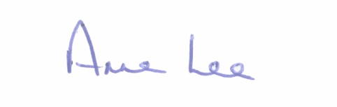
Signed: _______________
Anne Lee,
Meetings Administrator.

Confirmed and adopted at Ballymahon Municipal District Meeting held on the
26th July 2018.

Signed: _______________
Cathaoirleach.

